INNOVATION FOR WEBSITE TRAFFIC ANALYSIS

Unsupervised Learning
With the rapid increases in the size and complexity of data, unsupervised learning will be the trend in the future . It tries to find relationships between the inputs without having any prior knowledge of the outputs. In other words, the aim of unsupervised learning is processing data for knowledge discovery, and using the knowledge for reasoning and decision making. Clustering algorithms are one of the mostly used unsupervised learning processes. These algorithms are used to categorize the input data into distinctive clusters (i.e., groups) by examining the similarity between them. Each observation within the same cluster is having greater similarity as compared to the observation in other clusters . Several clustering algorithms have been proposed and used over the past few years.
K-means
K-means algorithm is the oldest and popular partitional method . It is well known for its efficiency in clustering large-scale data sets. It aims to partition the data into K clusters based on a similarity measure.. Each cluster has a category centre µk. The Euclidean metric is selected as the criterion of similarity. The sum of squares of the distance between the points in each cluster to the centre of the cluster µk is calculated to minimize the sum of squares within each cluster. The objective function is written as: V = X K i=1 X N n=1 ||xi − µk||2 where x is the sample to be clustered, N is the number of samples and K is the number of clusters. K points are randomly selected from the datasets as the initial clustering centre. The Euclidean distance from each sample to the cluster centre is calculated. The sample is returned to the nearest cluster centre. The new clustering centre is obtained by calculating the average value of the newly formed data objects of each cluster. If there is no change in two successive iterations, it shows that the sample adjustment is over and the clustering criterion function has been converged.
Density-Based Spatial Clustering of Applications with Noise
DBSCAN is one of the most popular unsupervised learning algorithms. It aims to use the density in order to divide the samples of the dataset into various clusters . Specifically, it partitions the dataset into different clusters using two parameters, and MinPts (the minimum number of points to create a cluster). Any data object that does not fit into any cluster is considered an outlier. That is why unlike K-means and Hierarchical Clustering, DBSCAN can handle the outliers objects (i.e., noise) in the dataset. Its performance depends on the parameters settings (i.e., MinPts, ).
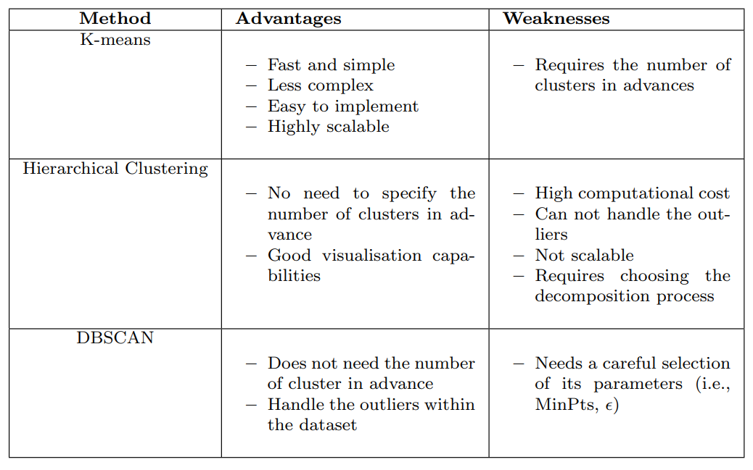

Davies-Bouldin Index
The basic principle of validity clustering is minimizing the intra-cluster distance or maximizing the inter-cluster distance. Bouldin Index (DBI) to measure inter and intra-cluster distance and find the ideal number of clusters , which is calculated as follows: DBI = 1 K X K i=1 max i=| j ( ˆdi + ˆdj ) di,j where K is the number of clusters, ˆdi is the average distance between each object in the ith cluster and the centroid of the ith cluster, ˆdj is the average distance between each object in the jth cluster and the centroid of the jth cluster, and di,j is the Euclidean distance between centroids of the ith and jth clusters. A lower DBI means a better cluster configuration.
Silhouette Coefficient
The silhouette Coefficient (SC) measures how similar an object is to its own cluster (cohesion) compared to other clusters (separation). It evaluates the intra-cluster and nearest-cluster distance for each object. In contrast to DBI, the closer SC is to 1, the better the clustering result. In other words, SC ranges from -1 to 1. The coefficient equals -1 means clustering is wrong; 0 means indifference (same); and 1 means both clusters are far away. However, it is more computationally demanding than DBI. SC is calculated as follows: SC(i) = b(i) − a(i) max{a(i), b(i)} where a(i) is the average distance of the object xi to other objects in the same cluster as i, and b(i) is the minimum average distance from the object xi to objects in a different cluster (i.e., xi is not a member).

Flowchart /Working model
